iPad & iPhone App
Dinox is the ultimate Dino Quiz with spectacular
'Walking with Dinosaurs' video.

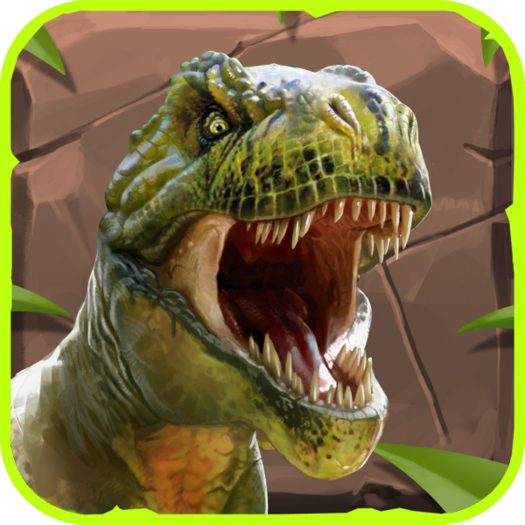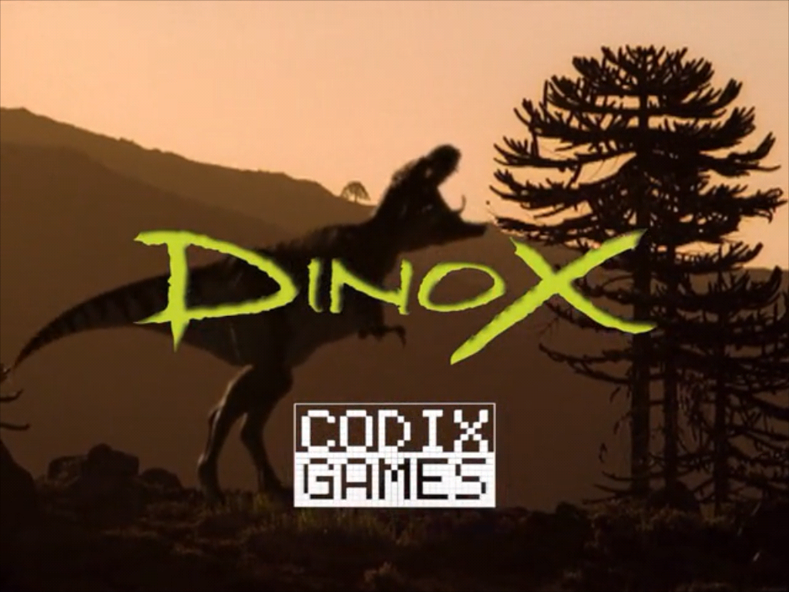

- Video, screenshots, information, and a direct link to the iTunes store. See our special Dinox Site (in 6 languages): www.dinoxgame.com
- You can download and play for free. This version contains 25 questions.
- Download the complete Dinox Press kit: http://www.codixgames.com/DINOX_PRESS_KIT/
- For questions, please contact:
Roger Avis, pr@codixgames.com

L. S.,

Codix Games is proud to announce the launch of "Dinox".

Dinox is now available worldwide in six languages ​​for the iPad and iPhone.

Dinox is the ultimate Dino quiz for children aged 6 to 16. And for anyone who loves dinosaurs.

Instead of "bare" questions, each question has a spectacular Dino clip from the famous 3D BBC TV series "Walking with Dinosaurs".

Collect the four skeletons for the museum and improve the highscore.

Attachment (s): Artwork from the Dinox App.

Best Regards,


Roger Avis
pr@codixgames.com
www.codixgames.com
The Netherlands

